Scenario 5: NACL scenarios & Security Group Scenarios
We have a scenario that, public instance (bastion host/ jumpbox) Is faced to internet, and it has allowed permission to anywhere. means anybody can take a rdp to the server.
In this scenario,
- We will block RDP from the internet but allow RDP from private subnet servers only.
- Even if security group allows rdp from anywhere, the NACL will block it – because NACLs take high priority and are stateless.
Stateless means what goes it won’t come out.
We need to allow outbound rule also to come out.

Step 1: Lets validate first
Lets take a rdp from laptop.
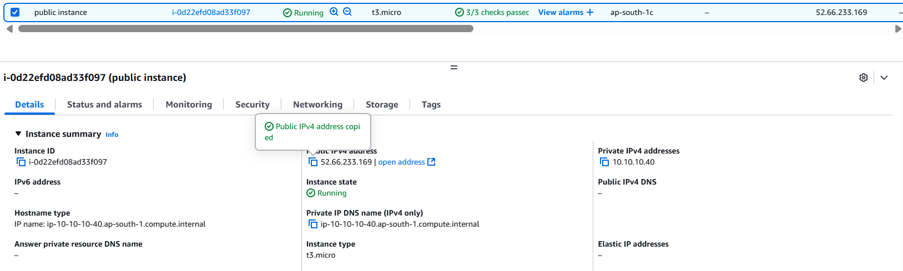
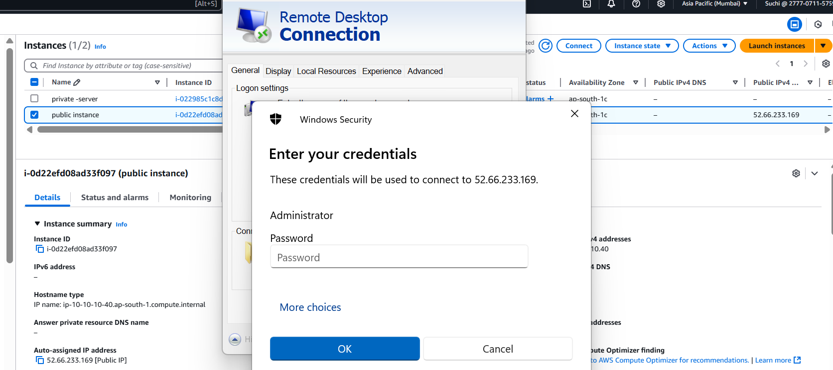
From the above image we can confirm that its allowing a public to access the server.
Let’s validate security group also
FYI – security group is like server firewall (class door)
And NACL is like subnet firewall/gate (school gate)
Even though your friend gives you an hope that he will let you come inside his classroom. Watch man won’t allow him to enter the school gate at the first go. if he as a rule (id card) then he is allowed to enter the school gate.
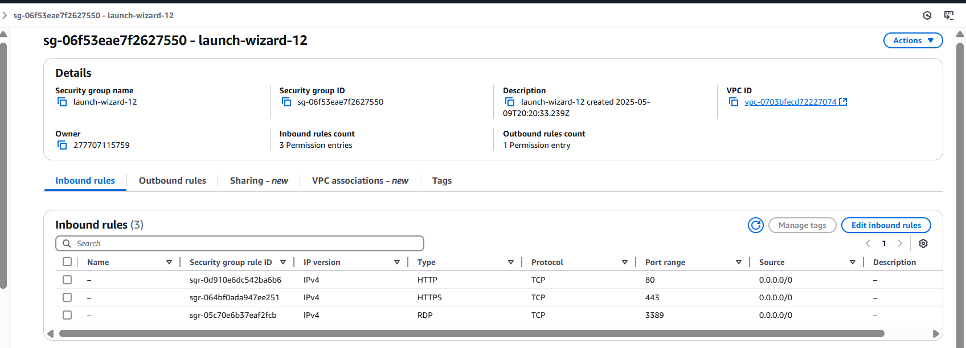

Step 1: Go to VPC > from the left panel scroll down to security under security select Network ACL’s
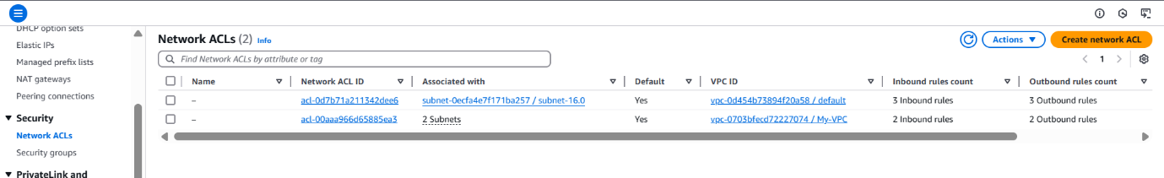

Step 2: Create
For Public Subnet:
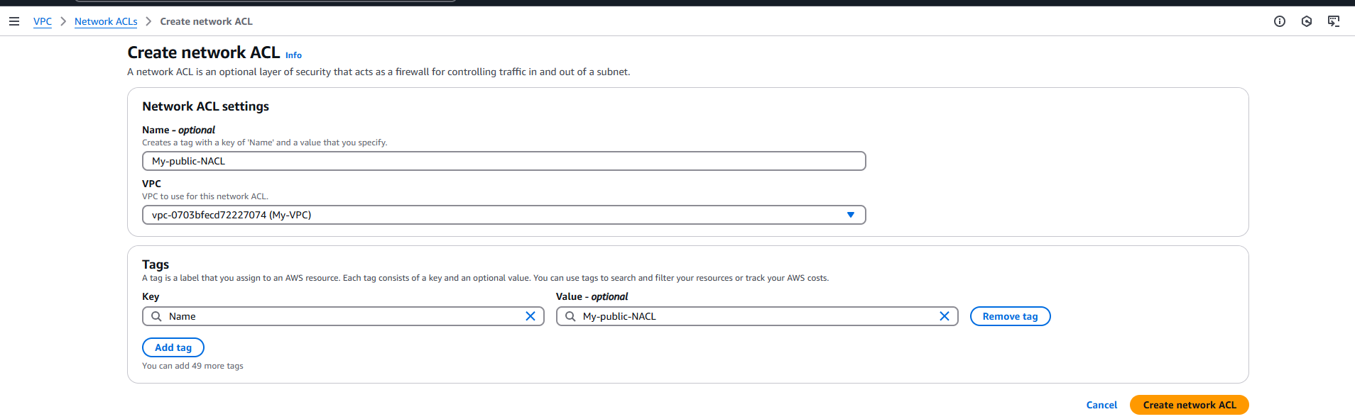
Note: when you create an NACL , by default all the inbound an outbound rule will be denied.
“ * “ star means everything , port , protocol , type.
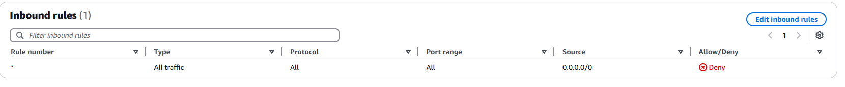
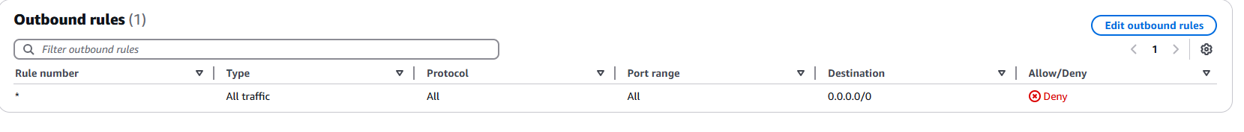
Step 3: lets Associate public subnet.
Click on the created NACL > scroll down and select subnet associations
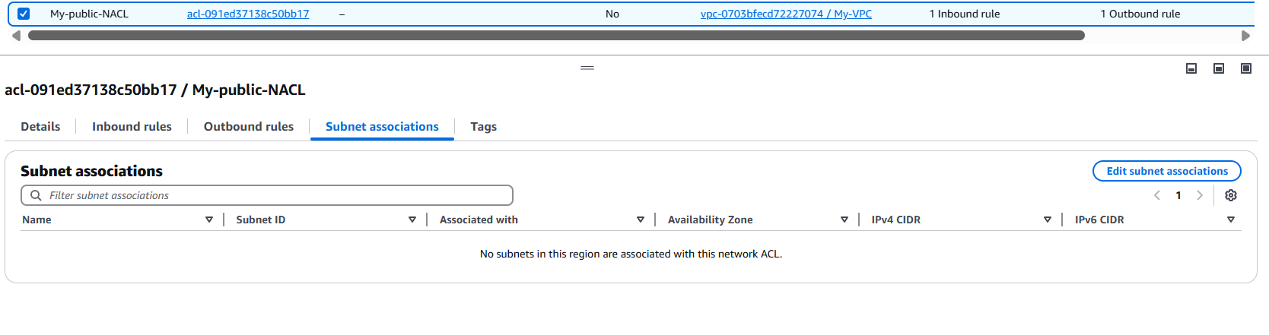
Step 4: click on edit subnet Association and add public subnet.
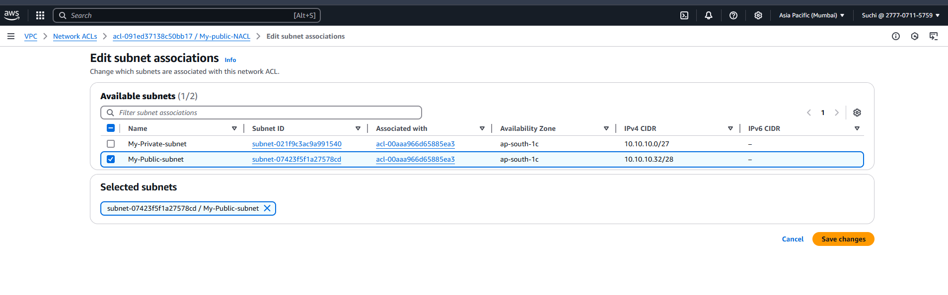
Step 5: Let’s create a rule.
Inbound Rules
Click on edit inbound rules
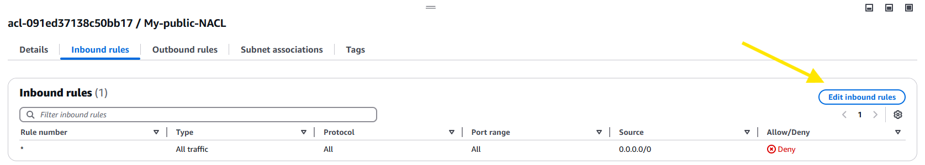
Rule | Type | Protocol | Port | Range source | Action
100 | HTTP | TCP | 80 | 0.0.0.0/0 | ALLOW
110 | HTTPS | TCP | 443 | 0.0.0.0/0 | ALLOW
120 | RDP | TCP | 33989 | 10.10.10.0/27 | ALLOW
130 | ALL | AL | * | 0.0.0.0.0/0 | DENY

-RDP is only allowed from private subnet 10.10.10.0/27
-Last rule denies everything else
-ANY rule after 130 will not matter (evaluation stops at first match)

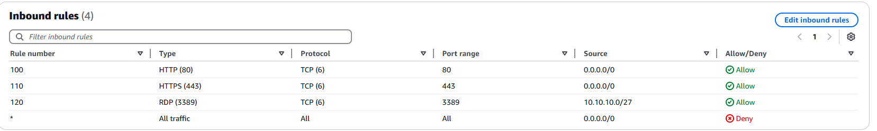
Outbound Rules
Rule | Type | Protocol | Port | Range source | Action
100 | ALL | ALL | * | 0.0.0.0/0 | ALLOW

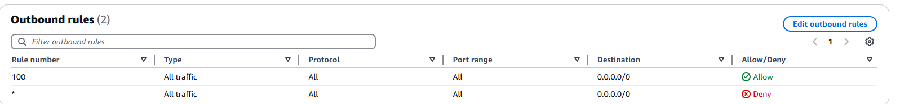
Why allow outbound?
Because NACLs are stateless.
If we allow inbound RDP,
we must also allow outbound traffic so the instance can send the response.
Otherwise RDP handshake fails
Note:
The DENY rule blocks everything else, like RDP from the internet.
Validate
Step 6: Test RDP from laptop (public internet).
Successfully
Even though SG may still allow RDP,
NACL denies it → so traffic is blocked.
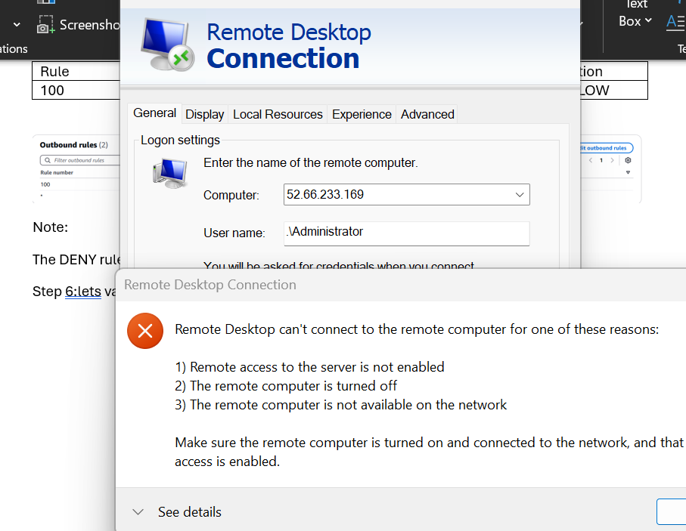
Step 7: Test RDP from a private subnet EC2 instance
If you connect from: 10.10.10.0/27
Result: SUCCESS (allowed by rule 120)

